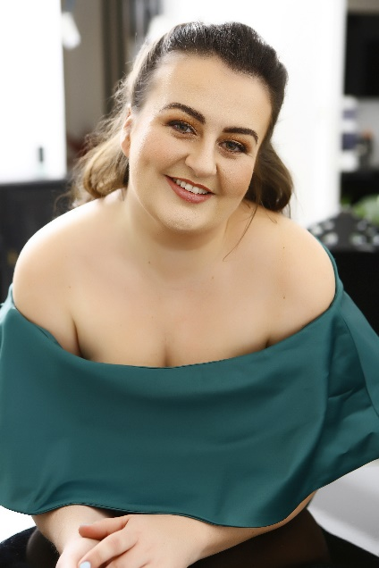
CLARE TUNNEY
(Soprano)

claretunney@hotmail.com +447913890587 D:O:B : 30/04/92
Current Work: Staatsoper Stuttgart – Soprano Soloist

Training: Royal Academy Opera 2018 - 2020
The Royal Academy of Music 2013 - 2018
(BMus, MA, DipRAM)

Born in Northern England, Clare is a Full-Lyric Soprano, based in Stuttgart, Germany. Since moving to Germany in 2020, she has worked for many esteemed companies including, Staatsoper Stuttgart, Frankfurt Oper, Dortmund Oper and Ludwigsburg Symphony Orchestra. She was a Scholar at The Royal Academy of Music for 7 years where she studied with Nuccia Focile, Mary Nelson and Jonathan Papp. In 2019, she spent 3 weeks in Tuscany, Italy, working on Bel Canto repertoire as part of the Georg Solti Accademia. In 2017, Clare placed 1st in the National Mozart Competition (UK), as well as winning the Art Song Prize in the Semi-Final. In 2019, Clare was a Semi-Finalist in the International Elizabeth Connell Prize for Aspiring Dramatic Sopranos, and a quarter finalist in the Tenor Viñas Contest. She also placed 2nd in the Pavarotti Prize (2019) and 3rd at London Song Festival’s English Song Competition. Clare was awarded the Sybil Tutton Opera Award (HMUK), John McAslan Prize, the Arthur Burcher Memorial Prize and placed 2nd in the Isabel Jay Operatic Prize (2016, 2017 and 2018).

ROLES
Helmwige Die Walküre Staatsoper Stuttgart,
Oper Dortmund (Einspringen)
Mutter Hänsel und Gretel Staatsoper Stuttgart,
Frankfurt Oper (Einspringen)
Erste Dame Die Zauberflöte Staatsoper Stuttgart
Pamina Die Zauberflöte Staatsoper Stuttgart
Iolanta Iolanta Royal Academy Opera (UK)
Fiordiligi (English) Cosí Fan Tutte Ryedale Festival Opera (UK)
Mimí La Bohème Westminster Opera (France)
Berta Il Barbiere di Siviglia Staatsoper Stuttgart
Fee Amaryllis Der Räuber Hotzenplotz Staatsoper Stuttgart
Papagena Die Zauberflöte Staatsoper Stuttgart
Frau Herz Der Schauspieldirektor Staatsoper Stuttgart
Nina Cherubín Royal Academy Opera
Lady Billows Albert Herring Samling Academy Opera
Arminda (English) The Garden of Disguises Ryedale Festival Opera Foresters Wife The Cunning Little Vixen Royal Academy Opera
3rd Spirit and Soldier Die Verurteilung des Lukullus Staatsoper Stuttgart

2023/24 SEASON
Mutter Hänsel und Gretel Staatsoper Stuttgart
Fee Amaryllis Der Räuber Hotzenplotz Staatsoper Stuttgart
Vierte Magd Elektra Staatsoper Stuttgart

OPERA SCENES
Tatyana Onegin Staatsoper Stuttgart
Blanche de la Force Dialogues des Carmélites Staatsoper Stuttgart
Rosalinde Die Fledermaus British Youth Opera Elettra Idomeneo Royal Academy of Music La Contessa Le Nozze di Figaro Royal Academy of Music Leila Les Pecheurs de Perles Royal Academy Opera Female Chorus The Rape of Lucretia Royal Academy Opera
Marie Antoinette The Ghosts of Versaille Staatsoper Stuttgart
Fiordiligi Così fan Tutte Staatsoper Stuttgart

2020/21 SEASON (Cancelled)
Rosalinde Die Fledermaus Staatsoper Stuttgart
Fiordiligi (Cover) Cosí Fan Tutte English National Opera
Chorus Glyndebourne Festival

ORATORIOS AND SYMPHONIES
Verdi Requiem (Romsey Abbey, Hexham Abbey and Guildford Cathedral, UK)
Mozart Mass in C minor (Ludwigburg Symphony Orchestra)
Haydn Creation (Durham Cathedral, UK), Nelson Mass
Beethoven Symphony No.9 (Guildford Cathedral, UK)
Mahler Symphony No.4
Mendelssohn Elijah
Rossini Petite Messe Solennelle
Brahms Requiem
Dvořák Stabat Mater
Tippet Child of our Time (Ely Cathedral)
Poulenc Stabat Mater (St. John Smith Square)
Mozart C minor mass (SJSS), Vesperae Solennes de Confessore, Missa Brevis in D major,
Handel Messiah (Arundel Cathedral)
​Fauré Requiem
Rutter Requiem
Duruflé Requiem
Britten Ceremony of Carols, Rejoice in the Lamb
Vivaldi Gloria
Goodhall Eternal Light
Schubert Mass in G, Stabat Mater (SJSS),
Bruckner Requiem
Biber Requiem
Bach Christmas Oratorio (1 and 6) (SJSS)

